Introduction

Overviews

Indian agricultural includes a mix of traditional to modern farming techniques in some parts of india traditional use of cattle of plough remains in use

Purpose;

India is a global agricultural power house its world largest producer of milk pulses and spices and has the world largest cattle herd buffaloes

Empathymap

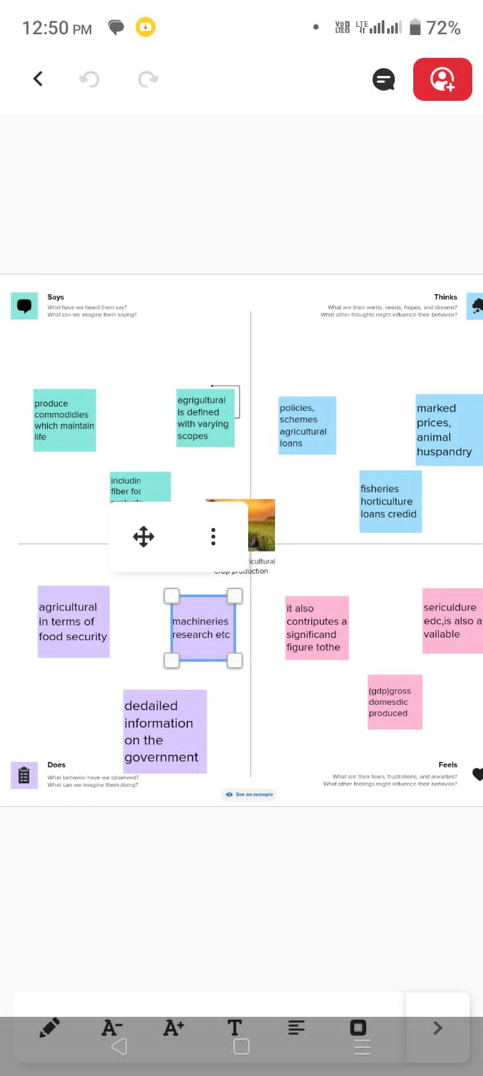

BRAINSTROMING



DASHBOARD

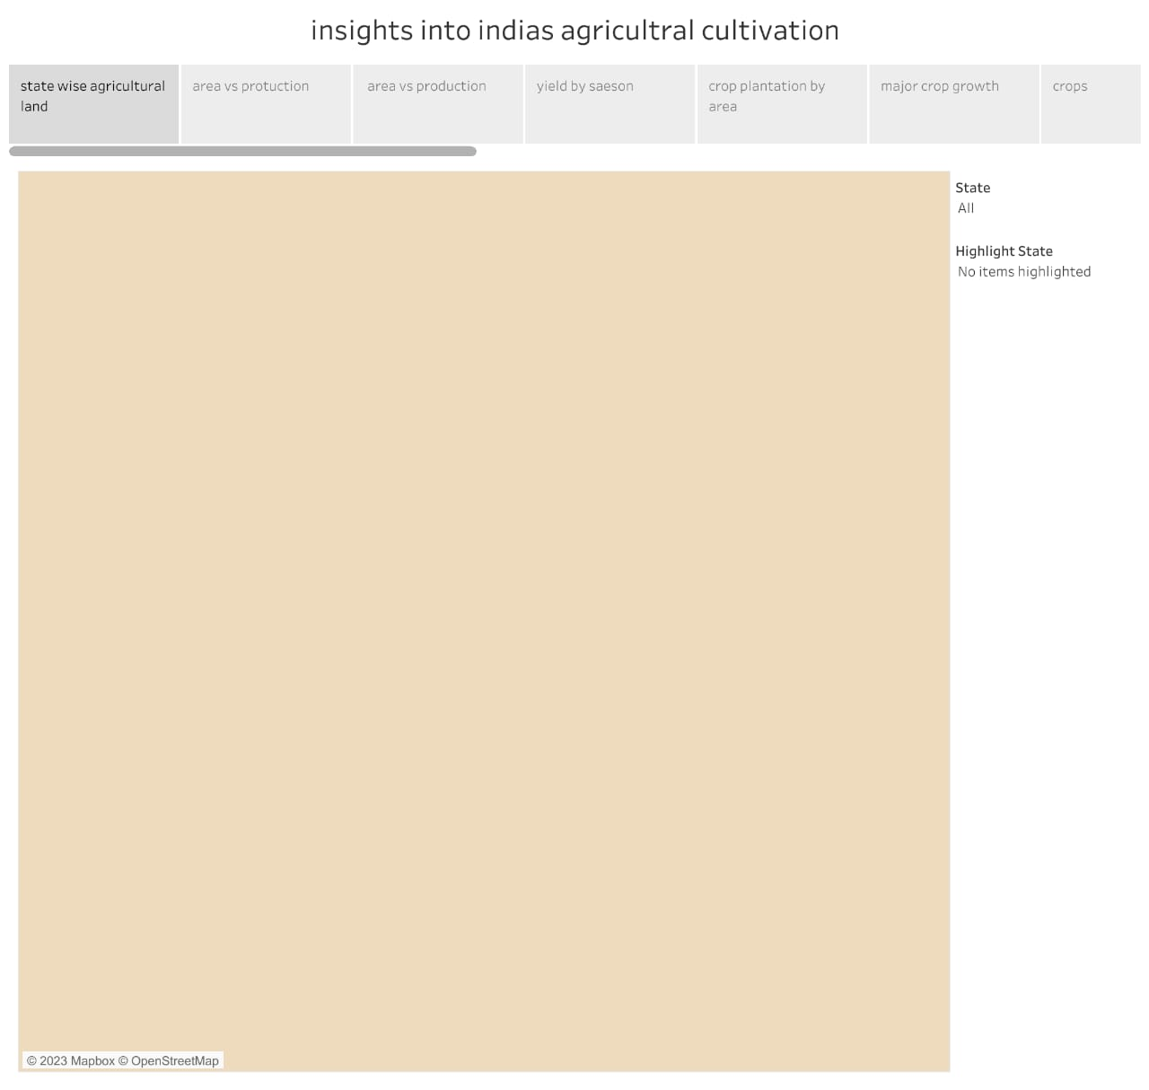

STORY

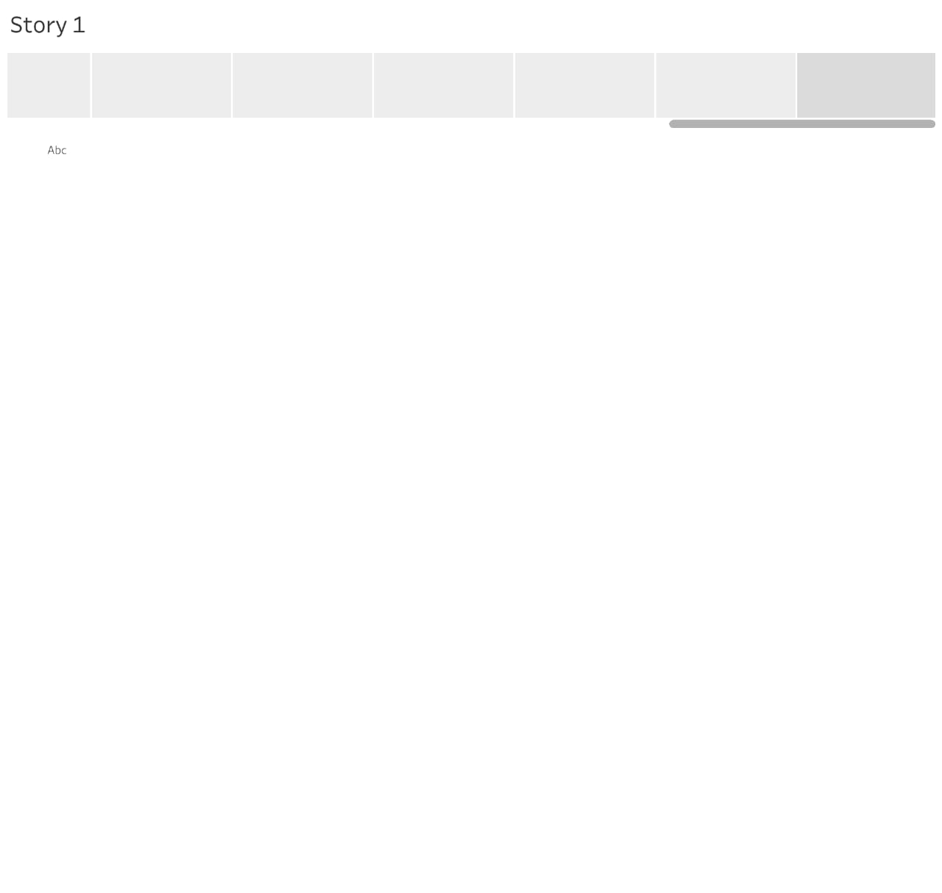

Agriculture impacts society in many ways, including:

supporting livelihoods through food, habitat, and jobs; providing raw materials

for food and other products; and building strong economies through trade.

DISADVANTAGES

Insufficient water supply

Lack of mechanisation

Agricultural indebtedness

Possible solutions for farming challenges

Inadequate lighting

Introduction of modern farming technology

Irrigation facilities

Limited land availability

No value processors for surplus production

FUTURE SCOPE

Due to globalisation, increase in household incomes and health

consciousness the demand for fruits and vegetables, dairy products, fish and

meat is going to increase in future. Research, technology improvements,

protected cultivation of high-value greens and other vegetables will be more.

CONCLUSION

Thus agriculture in india makes more efficient in people lives.